Tulip Medical
Quality System Procedure
QSP 9.1-9
Health Hazard Evaluation Procedure

Approvals

VP Regulatory Date

Q/A Date

Rev | Date | Description of Change
0 | 07/18/23 | New Release

Scope
This Health Hazard Evaluation (HHE) procedure is a Global Procedure for Tulip Medical. The HHE process supports the risk assessment process and quality system elements for investigations that may require additional review and disposition, whether further action, such as a field action, is required. This procedure is applicable to all regulated products released for distribution.

Purpose
Health Hazard Evaluations (HHEs): HHEs are assessments conducted to evaluate potential health hazards in workplaces or specific occupational settings. The purpose of an HHE is to identify potential risks to workers' health and provide recommendations for mitigating those risks.
The HHE process is intended to provide a health risk analysis tool when an individual significant event or trending of, Deviation Reports (DRs), Customer Complaints (CCs), Corrective Actions (Quality Deviation Reports or QDRs), etc., indicate an issue requiring additional analysis or potential action to prevent risk to public health.
To document the processes by which the possible risks to health associated with the condition of a distributed regulated products are evaluated and to enable a decision on any further field or subsequent actions required.

Definitions
Word / Phrase / Acronym | is defined as:
Field Correction Strategy | Planned specific course of action to be taken in conducting a specific recall, which addresses the depth of the recall and need for public warnings.
First Aid | A simple intervention that can be administered by a lay person. First Aid is not considered to be medical intervention. Examples of first aid are the application of a bandage, over the counter products, etc.
Health Hazard Evaluation (HHE) | A process by which a cross-functional team assesses potential risks to health associated with use of:  - Product released for distribution which may not meet specifications.  - Product that may not perform as intended.  - Product that poses a potential health risk not previously identified or occurring at a rate greater than anticipated.  - Product that may have been used in a way that is not intended by the manufacturer.  The process enables a decision on any further field or subsequent actions required.
HHE Committee | A cross-functional team, gathered to assess the possible risk to health presented by a specific issue and to render a consensus opinion on whether to recommend to the RAQA Leader that a field action be conducted.
Harm | Physical illness or injury to the health of patients and/or users.
Incident | “Any malfunction or deterioration in the characteristics and/or performance of a product, as well as any inadequacy in the labeling or the instructions for use which, directly or indirectly, might lead to or might have led to the death of a patient, or user or of other persons or to a serious deterioration in their state of health.”
Malfunction | The failure of a product to meet its performance specifications or otherwise to perform as intended. Performance specifications include all claims made in the labelling for the product. The intended performance of a product refers to the intended use for which the product is labelled or marketed.
Medical Intervention | Action undertaken by a health care professional to help treat or cure a condition that, if untreated, could result in permanent impairment of the eyesight or the eye.
Person Qualified to Make a Medical Judgement | A health care professional or a clinician, e.g. a doctor, a nurse, a biomedical engineer, a clinical expert, or a risk manager. The person does not have to be an employee of the firm but may be an outside consultant or the customer who is responsible to distribute the product.
Potential Reportable Events | An incident where a marketed product: -  - May have caused or contributed to a death or serious injury;  - Would be likely to cause or contribute to a death or serious injury if the malfunction were to recur.
RAQA Leader | VP of RA and Marketing
Serious Injury | An illness or injury that is either life threatening, results in permanent impairment of a body function or permanent damage to a body structure, or necessitates medical or surgical intervention by a health care professional to preclude permanent impairment of a body function or permanent damage to a body structure.
Violative or Potentially Violative | Distributed contact lens and/or contact lens care products that are considered violative or potentially violative of the laws administered by the appropriate Regulatory Agency. For example, product that is labeled with incorrect labeling specifications.

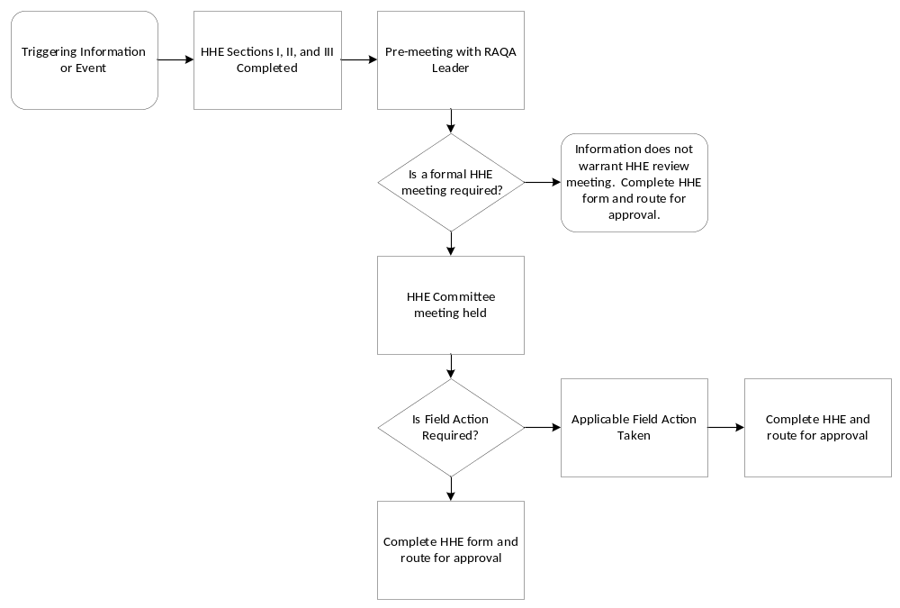

Procedure
  - The RAQA Leader for Tulip Medical or designee will be notified when the company becomes aware of information that released product in distribution:
    - may not meet specifications
    - may not perform as intended
    - may pose a potential risk to health not previously identified or is occurring at a rate greater than anticipated
    - may have been used in a way that is not intended by the manufacturer.
  - The RAQA Leader or designee will review the information regarding the product to ascertain whether the issue is consistent with existing risk analysis.
  - The RAQA Leader or designee will determine if a Health Hazard Evaluation (HHE) should be completed in the event that complaints or other data trending suggests that product may not be performing as intended. It is the discretion of the RAQA Leader for Company to determine if a pre-meeting is warranted for such cases.
  - Based on the Risk Analysis, the RAQA Leader will exercise their discretion to determine whether a HHE committee meeting should be convened.
  - HHE Review meetings will be scheduled with consideration towards the potential risk to health at issue. Representatives will be invited to participate in the meeting, as required. Appropriate internal or external consultants will be included dependent on the nature of the event. In the absence of certain representatives, RAQA Leader will determine whether sufficient representation is present to proceed with the HHE review.
  - The HHE Committee will review information on HHE form, and other related information, to evaluate the possible risk(s) associated with the event and document its recommendation on the Health Hazard Evaluation Form.
- Completing the Form
  - QA will complete the Product Data section of the form (Part I) with input from Supply Chain for distribution data and Regulatory Affairs.
  - QA will complete Problem Definition and Analysis (Part II) and Hazard Analysis (Part III), and will return the completed portions and any applicable supporting documentation to the RAQA Leader prior to the HHE meeting.
  - During the HHE meeting, the committee will discuss and determine:
    - The Conclusion and Review (Part IV). QA will record the HRI Rating.
    - The Strategy (Part V). The committee will record the decision regarding pursuing field action and/or if the event is regulatory reportable.
- Strategy
  - The Strategy (Part V) will record the decision to report to regulatory authorities as decided per GBL002 Global Adverse Event Procedure.
  - The Strategy (Part V) decision regarding Field Action will take into account the following factors to suit the individual circumstances of a particular event:
    - Results of the health hazard evaluation
    - Ease in identifying the product
    - Degree to which the product’s deficiency is obvious to the consumer or user
    - Degree to which the product remains unused in the marketplace
    - Continued availability of essential products
    - The decision to report to regulatory authorities per GBL002 Global Adverse Event Procedure
  - The Field Corrective Action Strategy decision will be recorded in Part V of the HHE form.
    - If no action is taken, rationale supporting the decision will be recorded.
    - If action is taken:
      - The type of action will be recorded.
      - If regulatory agencies are required to be notified of the field action, the date, method of reporting (certified letter, form, etc.), and countries notified will be recorded.
  - The decision of opening an associated CAPA will be documented based on the consensus of the HHE Committee Review Meeting.
  - Any applicable supporting documentation referenced in the form as an appendix shall be attached to the final HHE.
  - Upon completion of the HHE form, the completed HHE will be distributed as meeting minutes to the attendees of the meeting.
  - The completed HHE will be forwarded to document control for routing and approval
    - HHEs should be approved within 20 business days of initiation. The timeliness of the development and approval of an HHE shall be commensurate with the issue under review.
  - Approved HHE documentation will be retained in accordance with procedures for retention of quality records specific to risk management.

